Practical - 8
Practical Title: MySQL Schema Design, ER Model, PDO Connectivity, and Prepared Statements
Problem Definition: Design the database for StudentHub with students, events and registrations. Create PHP database connection using MYSQL statements.
Theory:
- Is the schema normalized properly?
Ans: Yes, the schema is normalized up to Third Normal Form (3NF).
- Are primary keys and foreign keys correctly defined?
Ans: Yes, primary and foreign keys are correctly defined to ensure entity and referential integrity.
- Is the database connection handled securely?
Ans: Yes, the connection is handled securely using PHP Data Objects (PDO) with best practices.
Implementation/ Output/Result :
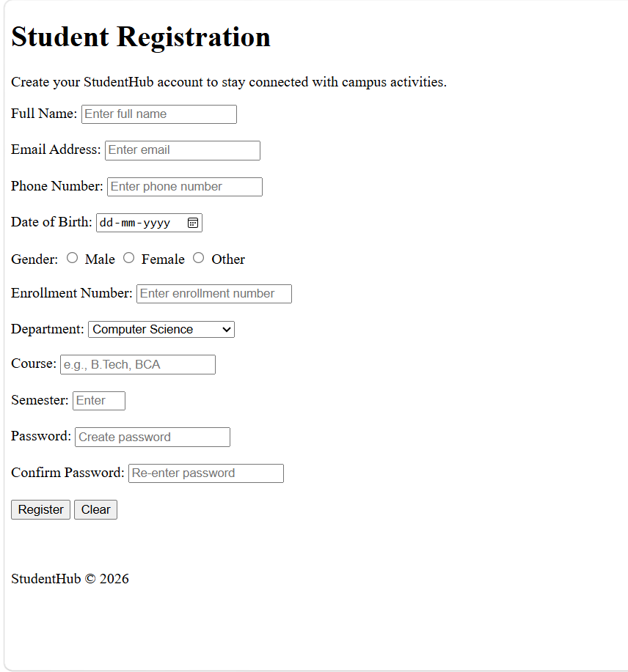
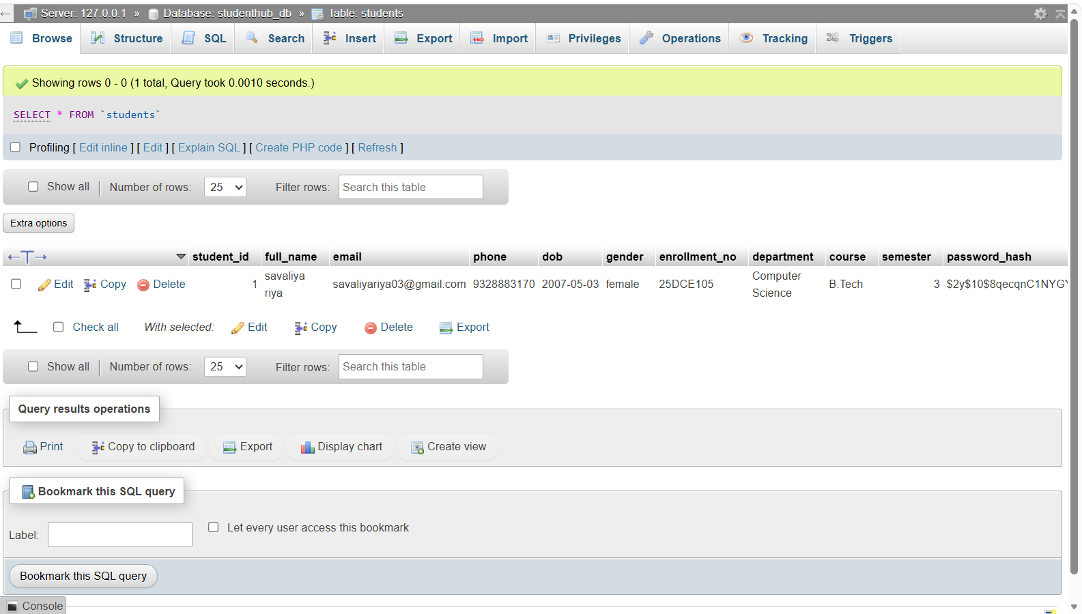
- GitHub Repository Link:
StudentHub/MySQL at main · savaliyariya03/StudentHub
- Challenges Faced:
I faced challenge in MySQL database how to code it and how to run it.
- Learning Outcomes:
Now I understand database connection with MySQL and I am able to understand this.
- Faculty Remarks:

